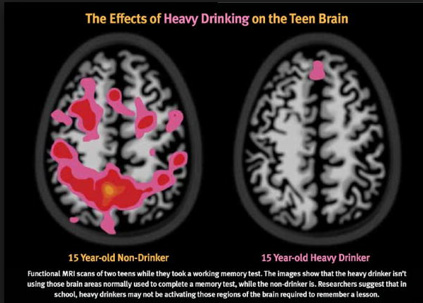  Paturel Amy. Buzz Kill: How does alcohol affect the teenage brain? Neurology Now.  2011; 7(6).23–24,26–28  WHICH BRAIN DO YOU CHOOSE? |  | Paturel Amy. Buzz Kill: How does alcohol affect the teenage brain? Neurology Now.  2011; 7(6).23–24,26–28  WHICH BRAIN DO YOU CHOOSE?
Paturel Amy. Buzz Kill: How does alcohol affect the teenage brain? Neurology Now.  2011; 7(6).23–24,26–28  WHICH BRAIN DO YOU CHOOSE? |  | Paturel Amy. Buzz Kill: How does alcohol affect the teenage brain? Neurology Now.  2011; 7(6).23–24,26–28  WHICH BRAIN DO YOU CHOOSE?

RESOURCES  Local district information can be inserted here. Include name and  contact information for the following resources:  - Guidance Counselors: Name, (XXX)-XXX-XXXX  - School Mental Health Counselors: Name, (XXX)-XXX-XXXX  - School Nurses: Name, (XXX)-XXX-XXXX  - School Social Workers: Name, (XXX)-XXX-XXXX  - Director: Name, (XXX)-XXX-XXXX  SAMPLE  Advocates or local mental health provider—  This may be regional –no number on this sample  Youth Central Intake and Care Coordination: 617-661-3991 |  | RESOURCES  Local district information can be inserted here. Include name and  contact information for the following resources:  - Guidance Counselors: Name, (XXX)-XXX-XXXX  - School Mental Health Counselors: Name, (XXX)-XXX-XXXX  - School Nurses: Name, (XXX)-XXX-XXXX  - School Social Workers: Name, (XXX)-XXX-XXXX  - Director: Name, (XXX)-XXX-XXXX  SAMPLE  Advocates or local mental health provider—  This may be regional –no number on this sample  Youth Central Intake and Care Coordination: 617-661-3991
RESOURCES  Local district information can be inserted here. Include name and  contact information for the following resources:  - Guidance Counselors: Name, (XXX)-XXX-XXXX  - School Mental Health Counselors: Name, (XXX)-XXX-XXXX  - School Nurses: Name, (XXX)-XXX-XXXX  - School Social Workers: Name, (XXX)-XXX-XXXX  - Director: Name, (XXX)-XXX-XXXX  SAMPLE  Advocates or local mental health provider—  This may be regional –no number on this sample  Youth Central Intake and Care Coordination: 617-661-3991 |  | RESOURCES  Local district information can be inserted here. Include name and  contact information for the following resources:  - Guidance Counselors: Name, (XXX)-XXX-XXXX  - School Mental Health Counselors: Name, (XXX)-XXX-XXXX  - School Nurses: Name, (XXX)-XXX-XXXX  - School Social Workers: Name, (XXX)-XXX-XXXX  - Director: Name, (XXX)-XXX-XXXX  SAMPLE  Advocates or local mental health provider—  This may be regional –no number on this sample  Youth Central Intake and Care Coordination: 617-661-3991

